The Brain – A student Guide.

- We have been trialling The Brain with BUS6A2 students during academic year 2012/2013.
- All learning materials will be included in The Brain (i.e. no module material is accessible on BlackBoard).

How to register with The Brain:
You will receive a no-reply email in your Regent’s email account.  You must register with The Brain as soon as you receive this email.  The Brain has a built in mechanism to delete access invitations if you does not access the system within a couple of days. | 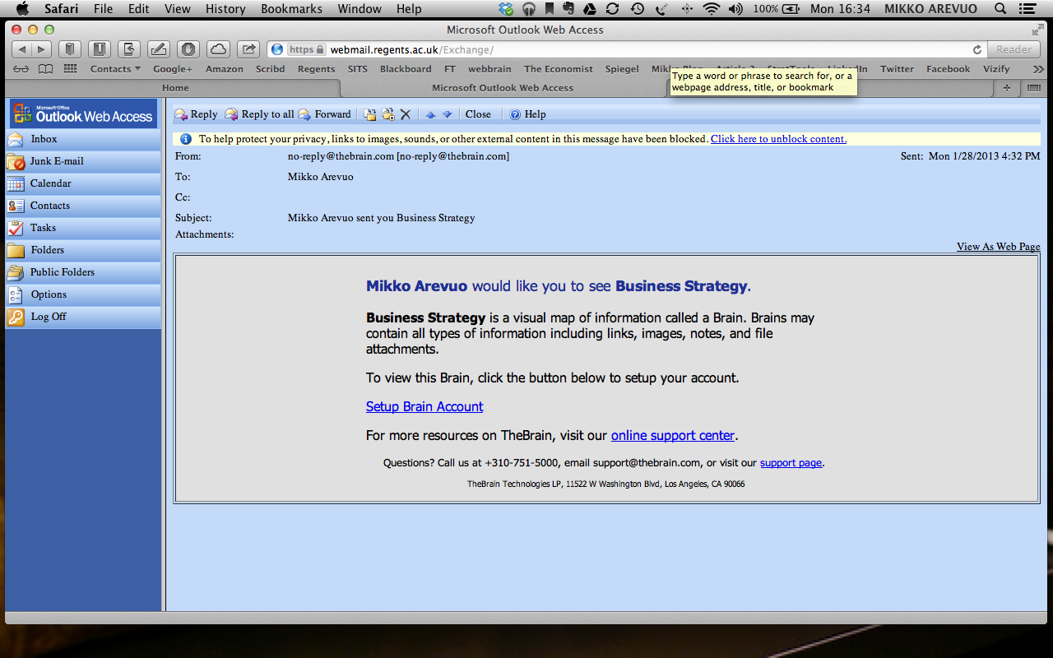
Once you have received your email click on the link ‘Setup Brain Account’.

If you have not received an email from The Brain please contact you tutor.

The link will take you to The Brain.  Fill in the following details: Username, First/last name, email and password.  Tick the you agree to the ‘terms’  Click on the ‘Sign Up’ button.  You can then access The Brain at http://www.thebrain.com/ at any time. | 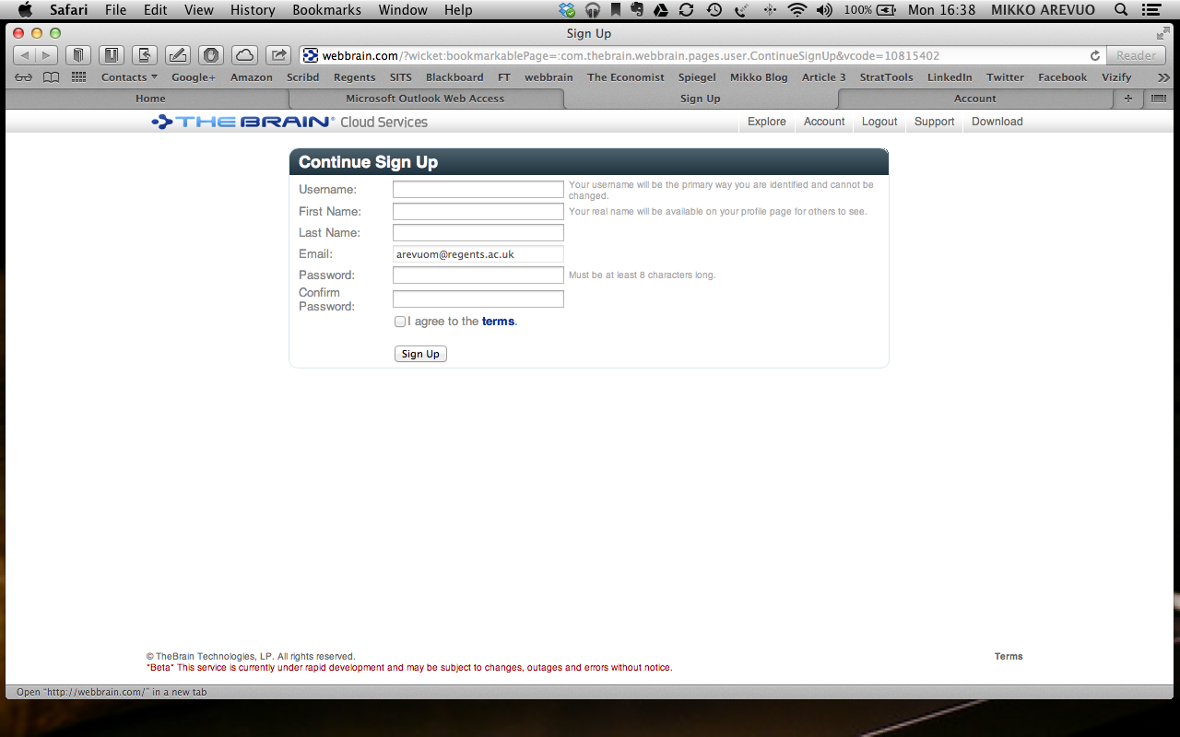

A brief guide to The Brain.

Once you sign in, you are able to access the top level of The Brain. | 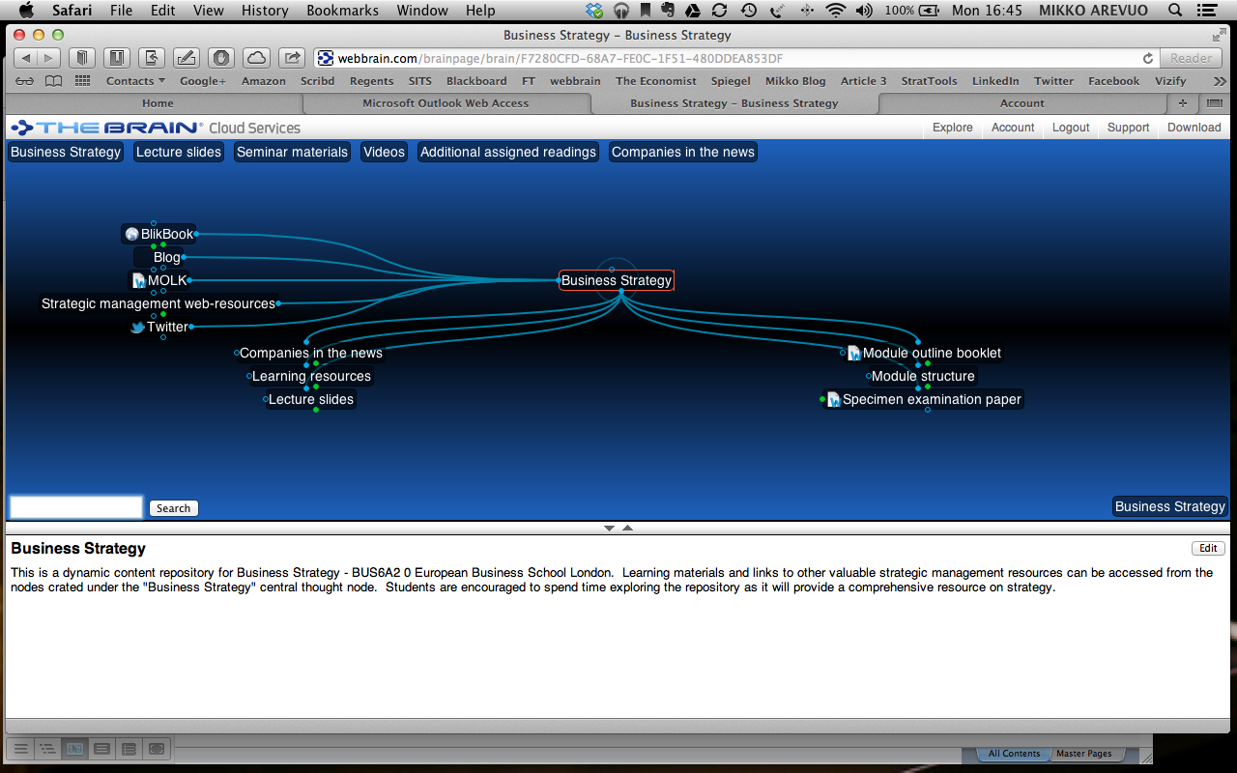
Each of the top-level nodes contains sub-nodes that allow you to drill deeper into the content of the course, such as video, web links, and additional articles.
An expanded Brain with all lecture slide nodes visible will look something like this.  Lecture slides are PowerPoint files that you can either download or open on your desktop. | 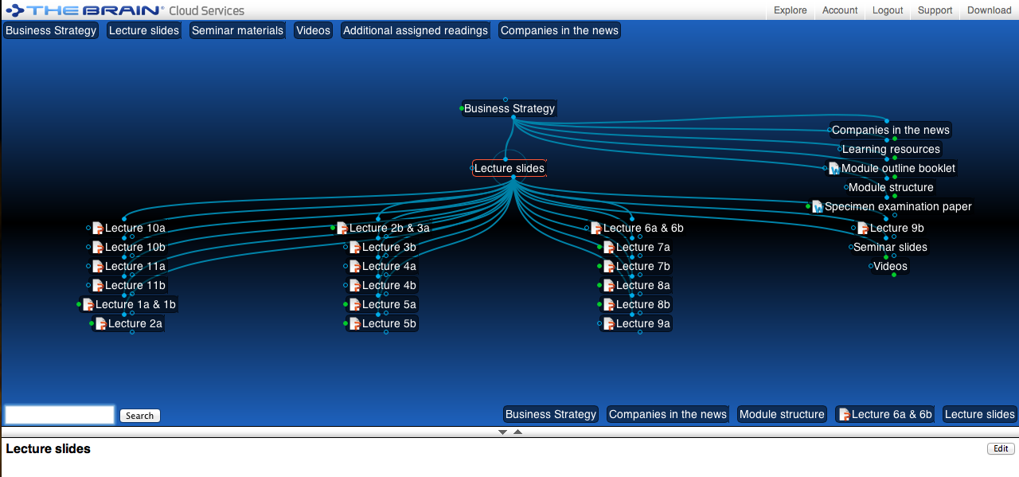
These links provide additional resources on how The Brain works | http://www.thebrain.com  http://www.thebrain.com/support/docs/

